**Version 1.15**

OPOS Installation Manual

08

**Fall**

Table of Contents

1 System Requirements 3

2 Download the Installation Package 3

3 Upload to Web Server Document Root 3

3.1 Linux/Unix Servers 3

3.2 Window Servers 3

3.3 Hosting Account 3

4 Extract the Installation Package on Document Root 4

4.1 Linux/Unix Servers 4

4.2 Windows Server 4

4.3 Hosting Account 5

5 Setting Up Folder Permissions 5

6 Run the Installer 6

6.1 Create Database User on a Hosting Account 8

6.2 Folder Permission Problem 8

6.3 PHP Version Problem 9

7 Installing PHP Printer Module 9

OPOS Installation Manual

# System Requirements

OPOS requires the following system/software installed on your server:

* Apache web server version 2
* MySQL database server version 5.0 or above
* PHP version 5.0 or above
* IonCube Loader extension loaded on your PHP
* PHP Printer module for Windows
* Curl extension loaded on your PHP

# Download the Installation Package

The OPOS Installation package (opos-1.15.tgz) is downloadable from the download page after you purchased it from shop.vitraining.com.

# Upload to Web Server Document Root

Next, upload opos-1.15.tgz to your Document Root folder. This is the folder where your web server serves it’s web document.

Please consult your hosting or Apache server’s settings and documentation for further details.

## Linux/Unix Servers

On Linux, it is usually located on:

/var/www/, or

/var/www/html/

Use your favorite FTP/SCP program to upload.

## Window Servers

On Windows, it is usually on:

C:\xampp\htdocs, or

C:\Program Files\Apache\htdocs

## Hosting Account

If you are installing on a hosting account, then you can use FTP/SFTP program or the web based File Manager to upload it to your Document Root folder.

On C-Panel hosting, you can use File Manager application to do this.

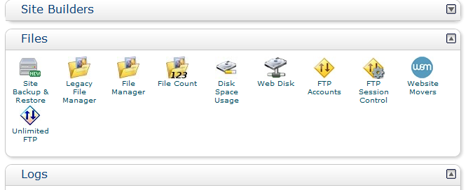

Then, on the File Manager, use the Upload button to upload the file.

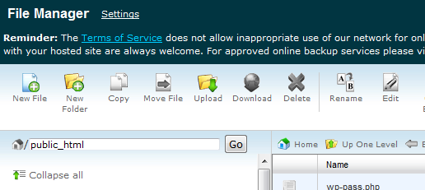

Put it into your Document Root folder, for example /public_html.

# Extract the Installation Package on Document Root

Next, extract opos-1.15.tgz on the Document Root folder. You can use any unzipping tools to extract this Tar Gzip file.

## Linux/Unix Servers

On Linux, simply use:

# tar xfzp opos-1.15.tgz

Once extracted, you will get a new folder on your Document Root, for example:

/var/www/opos, or

/var/www/html/opos

## Windows Server

On Windows, you can use 7zip, WinRAR, or other tools that are capable to extract TGZ file.

Once extracted, you will get a new folder on your Document Root, for example:

C:\xampp\htdocs\opos, or

C:\Program Files\Apache\htdocs\opos

## Hosting Account

On Hosting Account use your un-compress program provided by the hosting provider. On C-Panel Hosting, you can use File Manager to extract the file.

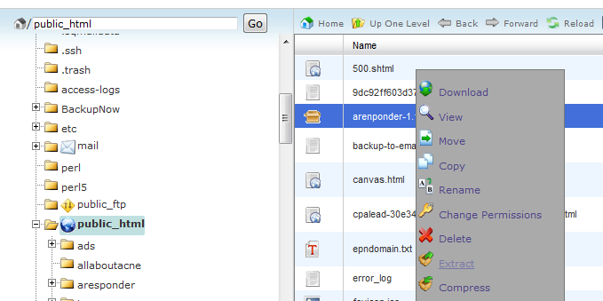

Once extracted, you will get a new folder on your Document Root, for example:

/public_html/opos

# Setting Up Folder Permissions

This step is necessary only for Linux servers.

To run correctly, OPOS requires some folders to be writeable by the Apache server it’s running on.

These folders are:

opos/

protected/runtime/

assets/

installer/

Firstly, check the user who runs your Apache server, by issuing the ps command:

# ps axu | grep httpd

Some example outputs of this commands are:

nobody 96101 0.0 0.2 113344 10372 ?? S 9:50AM 0:00.49 /usr/bin/httpd ...

or

apache 96101 0.0 0.2 113344 10372 ?? S 9:50AM 0:00.49 /usr/bin/httpd ...

or

www-data 96101 0.0 0.2 113344 10372 ?? S 9:50AM 0:00.49 /usr/bin/httpd ...

The first column of those outputs above is the user who runs the Apache server. The common users on Linux are: nobody, apache, and www-data.

If the user is nobody, then you need to change the mode for those folders into 777 (world writeable). So, issue this command:

# chmod –R 777 protected/runtime/

# chmod –R 777 assets/

# chmod –R 777 installer/

If your Apache server is running as users other than nobody, then you can set the ownership for opos folder for that user. For example is the user is www-data, then you can issue this command:

# chown –R www-data.www-data opos

The first www-data is the user name and the second is the group name (usually the same as the user name).

# Run the Installer

Next, go to your web browser and type the address of your OPOS server, for example:

http://<YOURSERVER>/opos

Of course, you can change <YOURSERVER> to your actual IP address or hostname.

If everything is ok, then the first page will be shown as follows:

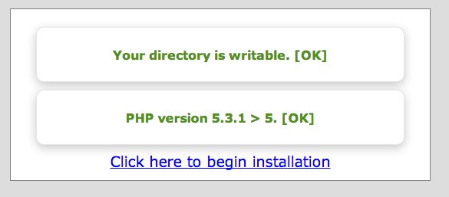

The installer will check the OPOS requirements:

* Your server folder permissions
* Your PHP version (minimum version 5.0 is required)

If everything is OK, then click the link to begin the installation process. The following page will be shown.

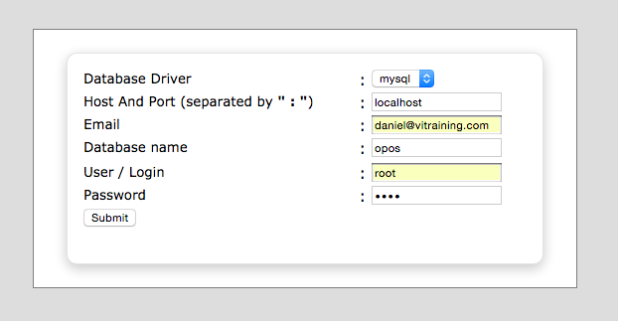

On the page, enter your database system parameters:

* **Database Driver**: currently only MySQL
* **Host and Port**: enter your database hostname (eg localhost, or IP address) and the port (if default port of 3306, the skip the port number)
* **Email**: enter your email address
* **Database Name**: enter the database name for the application. It will be created.
* **User/Login**: enter your database username that are capable to create new database (usually root). If you are using a Hosting Account, then you must first create this database username or use the default database username provided by the hosting company. Please refer the following section about *Create Database User on a Hosting Account*.
* **Password**: enter the above database username’s password.

Click Submit to begin the installation Process.

If some error happens, then a warning message will be shown on the page:

* **Failed! Connect to Database**: please make sure your username and password are correct and the username are actually exists on the database.
* **Failed! Database Name Has Been Used**: the database name is already exists on the database. Please use another database name.

If everything is OK, then you will see the main page of OPOS.

## Create Database User on a Hosting Account

If you are installing on a hosting account, then you need to supply the correct database username and password. You can use the default database username provided by your hosting provider or you can create a new one for OPOS.

On C-Panel Hosting, you can use **MySQL Databases** icon to manage your database and users.

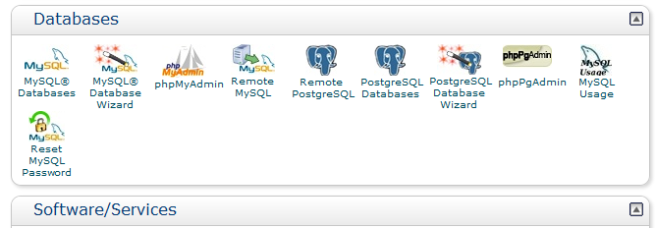

Then on the MySQL Databases page, scroll down and look for MySQL Users section. There you can create a new user and set the password for OPOS. For example,

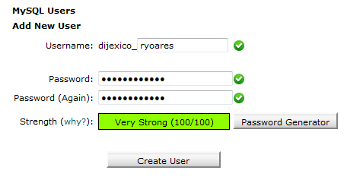

opos

The user name is prefixed with your hosting account name, so if your account is *dijexico* and your chosen database username is *opos*, then your database username is **dijexico_opos**.

You can set your own database password, or use the **Password Generator** facility to make the password stronger.

Then click on the **Create User** button to create the database user.

## Folder Permission Problem

If one or more folders that OPOS needs to write is not writable by the Apache Web server, then this warning message will be shown:

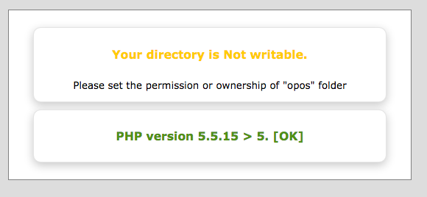

To fix this problem, please refer the previous part on *Setting Up the Folder Permissions*.

## PHP Version Problem

If your PHP Version is lower that version 5.0 then the Installation can’t proceed. Please upgrade your PHP Version up to minimum version.

# Installing PHP Printer Module

This step is only for Windows servers. OPOS needs the PHP printer driver in order to be able to directly access the POS printer and the Barcode **Print**er as well. We then need to install the PHP extension called php_printer.dll. This extension must be enabled in your PHP and phisically exists at the ext or extension folder under PHP.

The driver file is available on this folder: htdocs\opos\db\php_printer. There are many ZIP file containing the correct version of php_printer driver for your PHP.

To get the information of your current PHP version, go to this address:

<http://localhost/xampp/phpinfo.php>

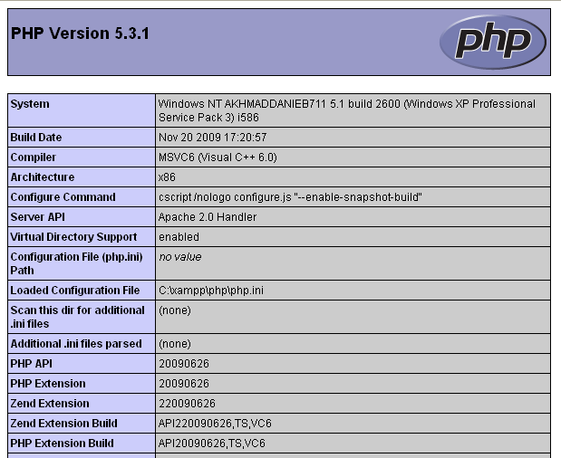

We can see that from the above example:

PHP Version: 5.3.1

Compiler : MS VC6

CPU Architectur: i586

PHP Extension Build: TS, VC6

Based on that information, we can determine the correct php_driver file:

php_printer-svn20100319-5.3-vc6-x86.ZIP

Extract the file, and we will get the php_printer.dll file.

Copy the php_printer.dll file to xampp\php\ext

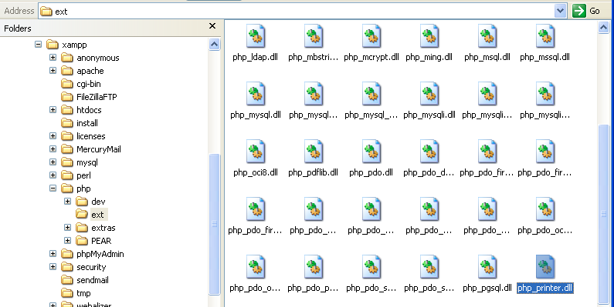

Then open and edit the file php.ini to enable printer_dll.

C:\xampp\php\php.ini

At around line 951, under the [extension] add the following line:

extension=php_printer.dll

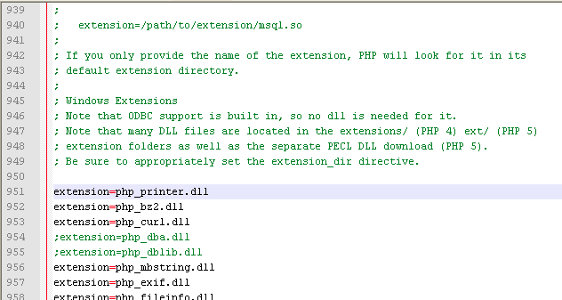

Restart Apache.

Go again to the address

<http://localhost/xampp/phpinfo.php>

Make sure that the printer driver is installed there.

